Instructions on Integrating the Affidavit
The Affidavit is a mandatory component of your exam submissions that signifies that you are the author of your work, have not submitted it previously for grading and have clearly identified contents not devised by yourself (f.e. paraphrased works or contents generated by AI).
When submitting a paper, create a section break for your appendices after the core text of your work:
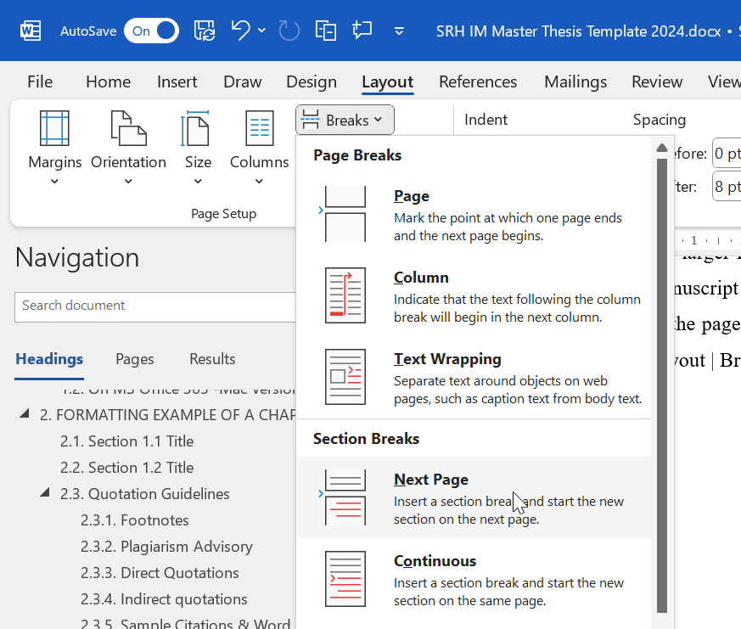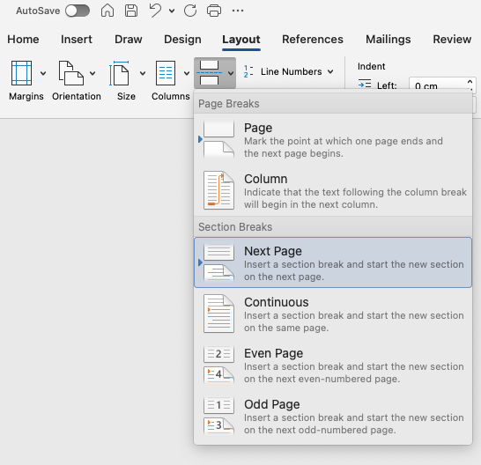
Use a new page numbering format (such as Arabic numerals flanked by hyphens) and start numbering at 1:
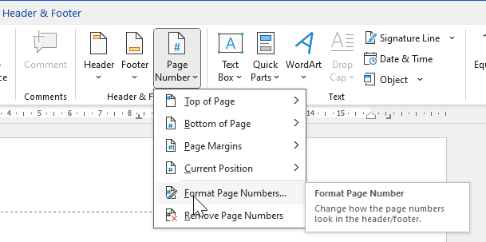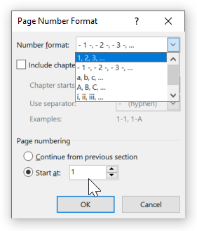
After any appendices you might have of your own, as well as your list(s) of sources, paste the affidavit contents into your submission document. Adapt the headings to the same formatting style as your own work.
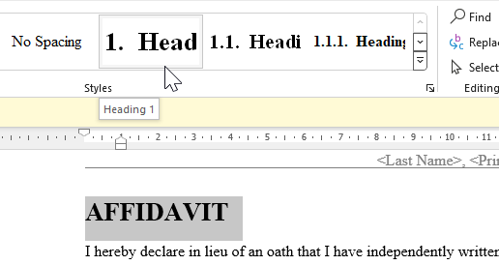
In the ‘List of Generative AI Tool Usages’, Check any of the listed items that apply to your work.
In the affidavit sections, fill in the title(s) of your work and your name. You may digitally sign the affidavit and the legal notice if only a digital submission of your work is required. Please sign any paper print outs in hand.

Good luck on your submission!

